SkillsinAction Photo Competition 2017 Submission Form
Personal Information
Last Name: Click or tap here to enter text. First Name: Click or tap here to enter text.
Country: Click or tap here to enter text.
Age: Click or tap here to enter text. Gender: Click or tap here to enter text.
Birthday: Click or tap here to enter text.

Contact Details
By providing the information below, you agree to give permission to UNESCO-UNEVOC International Centre to (I) contact you for the purpose of the Skills-in-Action Photo Competition and (II) to share your contact details to its affiliate entities shall there be any interest to independently commission you in the form of, but not limited to, engaging you as a photographer or buying other products of your work.

E-mail*: Click or tap here to enter text.
Tel. no: Click or tap here to enter text.
Mobile no*: Click or tap here to enter text.

Entries
Snapshot of photo | Title of the Photo | Description (not more than 100 words in one paragraph) | Indicate if digital manipulation was made


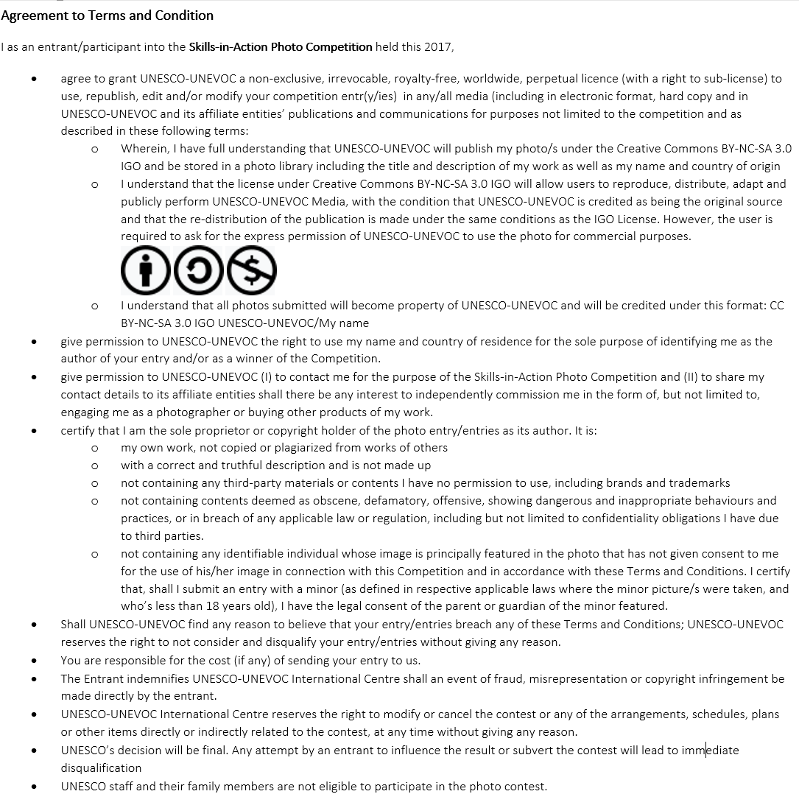

I hereby acknowledge that I have read and understood the terms and conditions as provided herewith and as stated in in regards to participating to the 'Skills-in-Action Photo Competition’ organized by UNESCO-UNEVOC International Centre and I agree to all of the terms. I also certify that all the information submitted to this form is true and correct.

Date

____________________________________
Signature above written complete name

